LSQL: Student-Manage System Based on I-Node FS
Members ：全秦霄、李宇扬、李伟杰、石寒雪
Content
1 Experimental Purpose 2
2 Experimental Design Ideas and Processes 2
2.1 Overall Structure 2
2.1.1 Communication structure 2
2.1.2 File system 5
2.1.3 The file structure of the project 8
2.1.4 Project function overview 9
2.1.5 System commands 10
2.2 Technical Analysis 11
2.2.1 Communication protocol 11
2.2.2 Option management - Opcode 13
2.2.3 Basic implementation of file system 14
2.2.4 Reading and writing large files 16
2.2.5 Inode dynamic expansion 16
2.2.6 System snapshot and recovery 17
2.2.7 Inter class design of student management system 19
2.2.8 H2S read write protocol 20
2.2.9 Database operation of inherent information 20
2.2.10 User group design 21
2.2.11 Permission technology 21
3 Instructions for Running the Experiment 24
3.1 Preparation 24
3.1.1 Prepare MySQL 24
3.1.2 Preparation for the database:SQL 25
3.1.3 Preparation for the visitor 26
3.2 How to Use 26
3.2.1 Start the server-side 26
3.2.2 Start the user-side 26
4 Presentation of Experimental Results 26
4.1 Display Sequence Chart 26
4.2 Result 28
4.2.1 Basic operation of the student management system 28
4.2.2 System command 36
4.2.3 Associated database student management system operation 39
5 Description of Contributions from Group Members 41
5.1 Overview 41
5.2 Detailed description 41

Experimental Purpose
This large assignment for an operating system required a team of students to develop a student performance management system using a server-client architecture with multi-user access. System users include administrators, teachers, and students, each with different functional privileges. The project is based on OS file management and process communication principles, with special emphasis on the use of the I-Node file system and Pipe inter-process communication. In the project, we not only have to implement basic functions, such as user and file management, system backup and recovery, but also have to pay attention to resource protection, such as the use of mutex locks. In addition, the project provides optional implementations of additional features, such as ways to handle files exceeding I-Node capacity limits, using socket sockets for inter-process communication, implementing file snapshots, and so on，which we all implemented. Through this project, students can gain a deeper understanding of the internal mechanisms of the operating system and improve their programming and problem-solving skills.

Experimental Design Ideas and Processes

Overall Structure

Communication structure
- Diagram of the communication structure
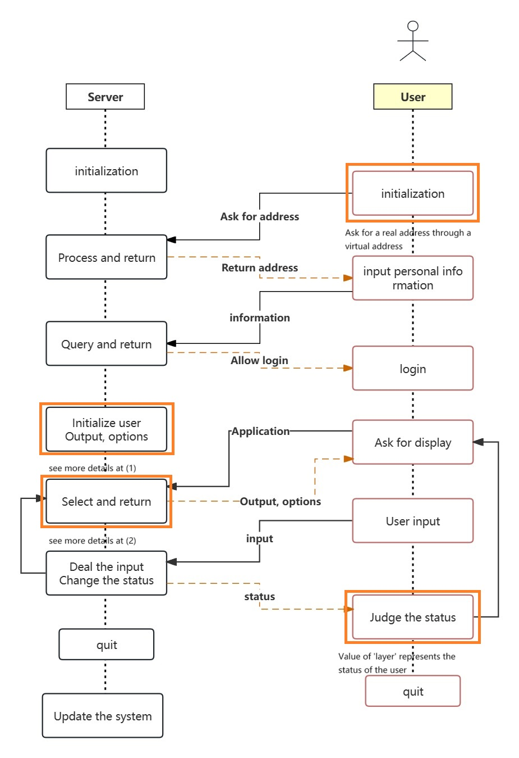
  - Initialization of the User
After the user successfully login, the system will initialize two strings which make up the output. See the graph for more details.
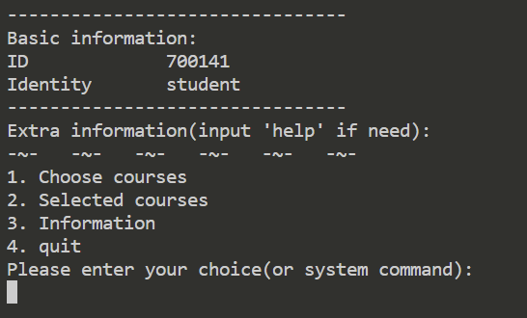
Personal information: Between the two dotted lines, it is always displayed at the beginning.
Output: Above the wavy line, it is used to output additional information.
Options: Below the squiggly line, it is only used to display option information.
  - Select and Return
At the beginning of each loop, the user will apply for the display option. The system will return a package containing the output and options strings.
For more information about how to filter options, see 2.2.2
- Network Configuration
More information about Custom Protocol (2.2.1)
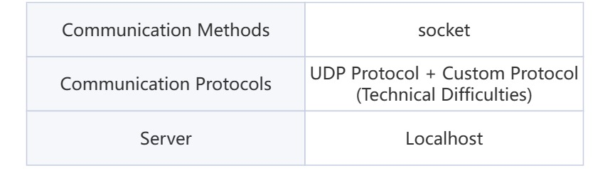
- Separation
The system achieves a high degree of front-end and back-end separation, and the back-end integrates all processing functions.
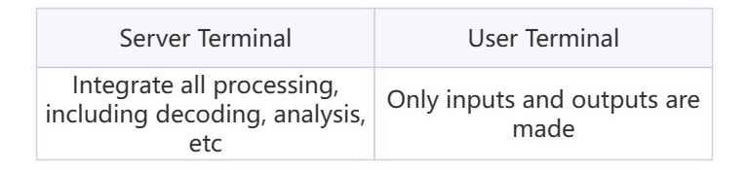

File system
- Disk Partition
The entire project uses the disk.txt file to simulate a disk.
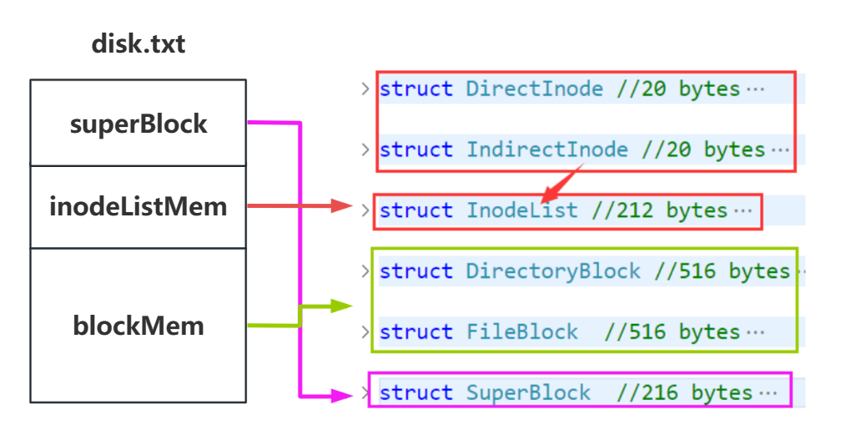
Disk partitions are designed to be divided into three parts. The data types corresponding to each partition are also shown on the right side of the figure above.
- superBlock: Put the bitmap, maximum usage, size of each partition, total disk size, and inodeList location in the disk into the superBlock.
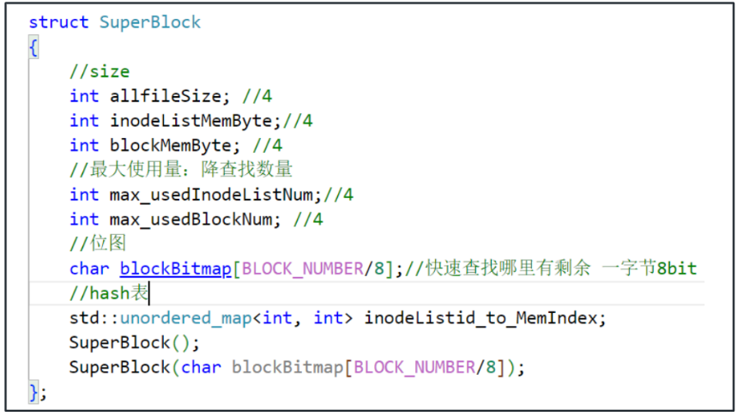
- inodeListMem: In inodeListMem, inodeList is used as the unit to build the memory partition. For inodeList, it contains whether it is full, the status information of the level, and an inodeMem in inode units.
- Inode types are divided into DirectInode and IndirectInode.
- They are all 20byte in size.
- DirectInode stores the file information (blockID, fileType), inode information (InodeNumber, inodeType), and permission information represented by the inode.
- IndirectInode stores the inodeList information (pointLevel, inodeListID) and inode information (InodeNumber, inodeType) pointed to by this inode.
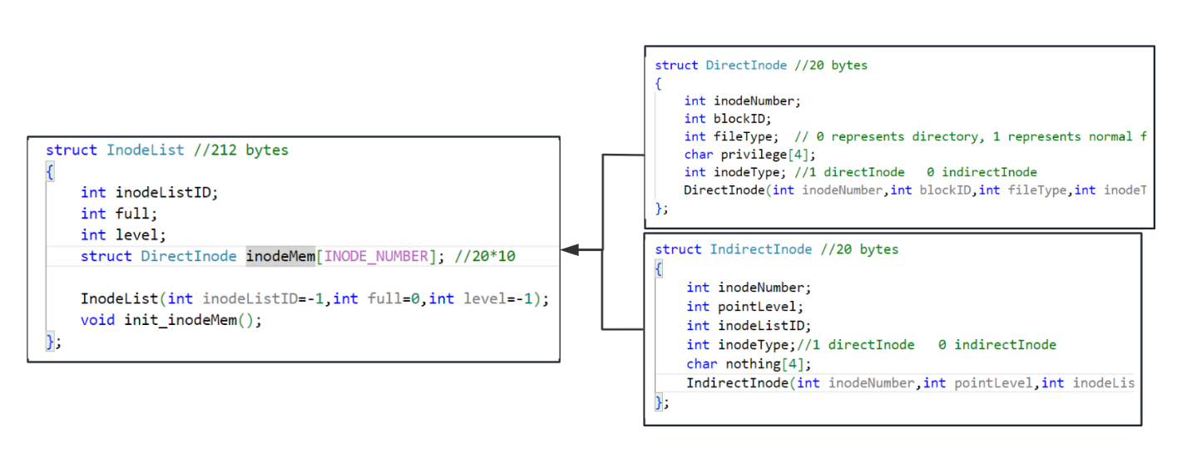
- The unit in BlockMem is block. The types of blocks are divided into FileBlock and DirectoryBlock.
- They are all 516byte in size.
- FileBlock stores blockType, file content, and pointers to extension blocks.
- DirectoryBlock stores blockType and directory entries (fileName, inodeID).
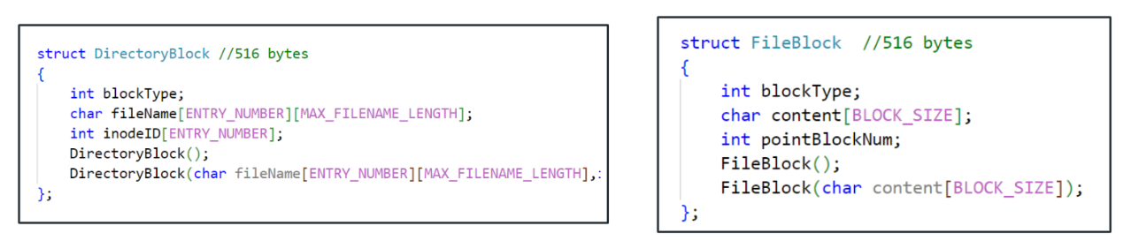
- The relationship of this file system to the existing inode system
- Differences: (The idea is the same, just the naming is different)
- The basic unit for building partitions is not inode, but inodeList.
- Extension items are stored in inodeList instead of DirectoryBlock. (It’s just a difference in naming, the idea is the same).
- Same point：
- All design ideas are modeled on the classic inode file system
- Inode expansion still uses the method of storing pointer addresses to achieve multi-level expansion. In other words, the second-level expansion still stores pointers for pointers.
- The basic unit of construction not only stores inode items, but also stores the basic information of the structure.
- SuperBlock, fileBlock, and DirectoryBlock have the same design.
- Improved advantages:
- Involves inode expansion, so the improved inode file system more clearly divides the physical locations of inodes and files.
- Loading inode items with inodeList can independently adjust the number of expansion items for inode expansion without affecting the block size.
- The size of the inodeList can be selected more appropriately to make the best use of the resources and reduce the waste of DirectoryBlock.
- Improved Inode file system
This figure shows the expansion ideas of inode expansion. Provides three levels of dynamic expansion.
- If it is fully full in the current state, the inode space of the next level will be dynamically expanded.
- In the figure, you can see that there are two inode types: yellow DirectInode and green IndirectInode. They point to the data and inodeList blocks respectively.
- When initialized, the shape of the file system is as shown in the upper left corner figure. At this time, there is only one inodelist.
- Inode0 of InodeList0 is reserved for block0, which is used to store the root directory.
- During expansion, change the data block pointed to by the original directinode to be pointed by the outermost and top directInode.
- Under the current configuration, up to 1117 data blocks can be stored.
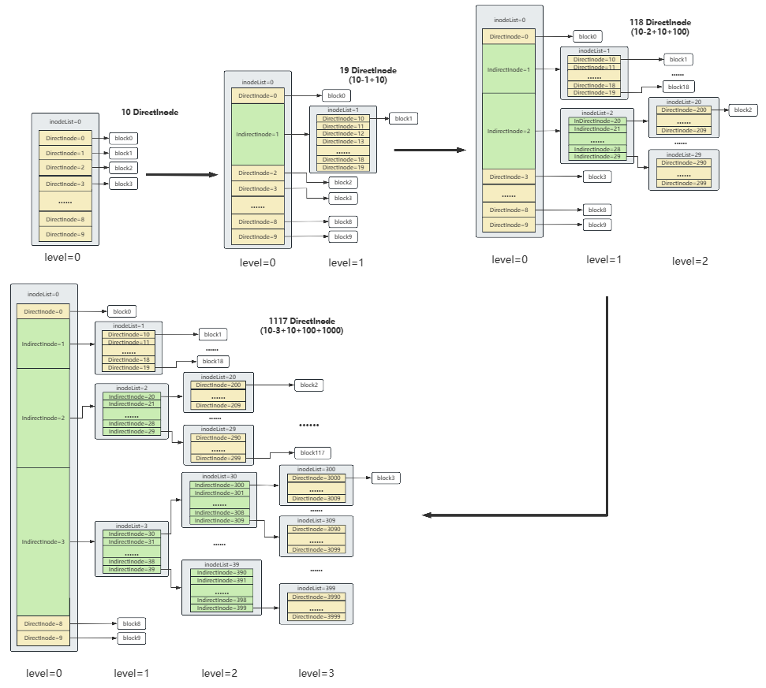

The file structure of the project
Based on the file system of 2.1.2, we have built the project file structure as shown in the figure for our project.
- The orange part is the file and information management of the student management system.
- Divided into three parts: Course, User and Group.
- Course: Stores course information and assignment content.
- User: stores basic user information.
- Group: stores group information. (Because our permissions involve group permissions)
- The green part is file and information management for file snapshot and recovery.
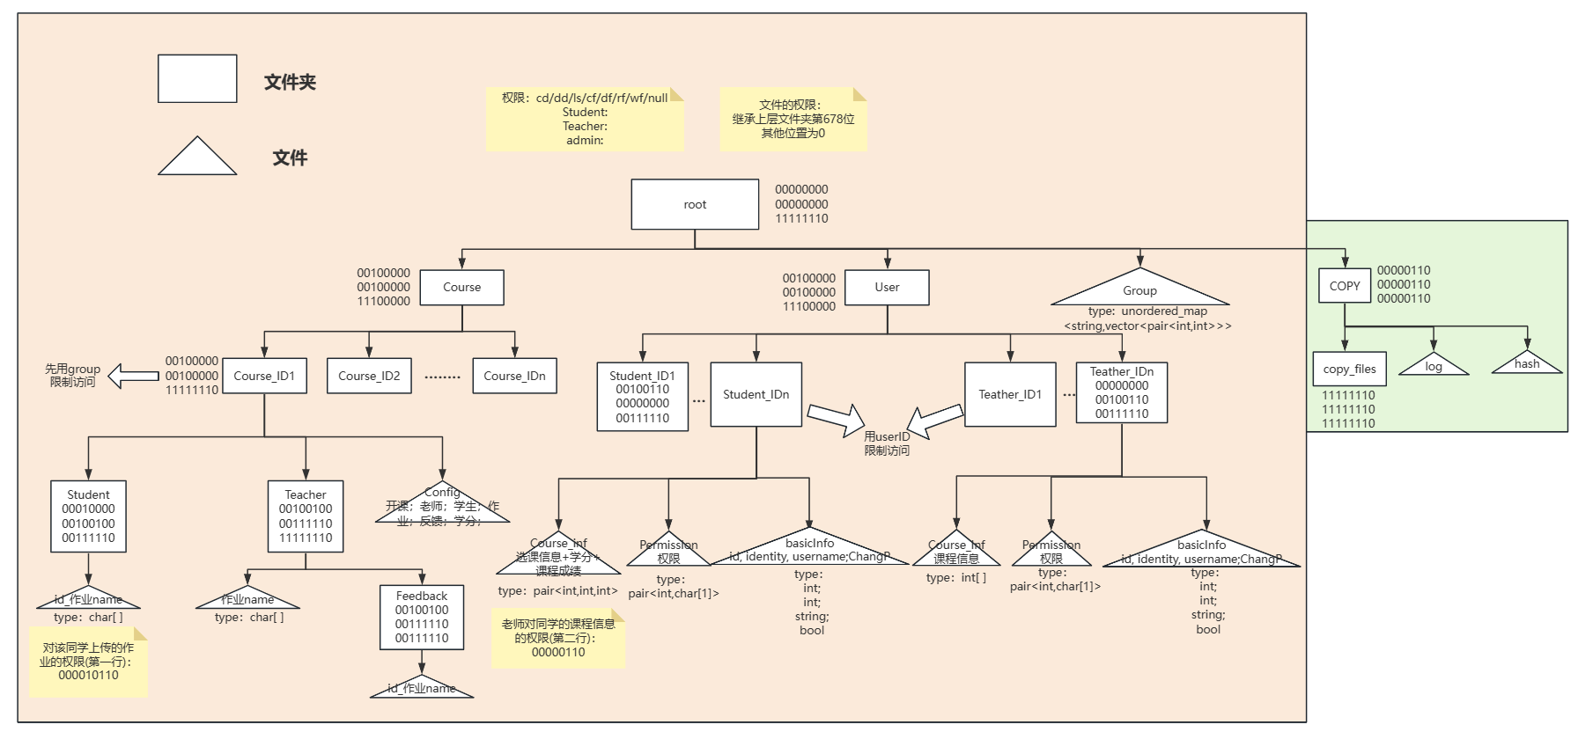

Project function overview
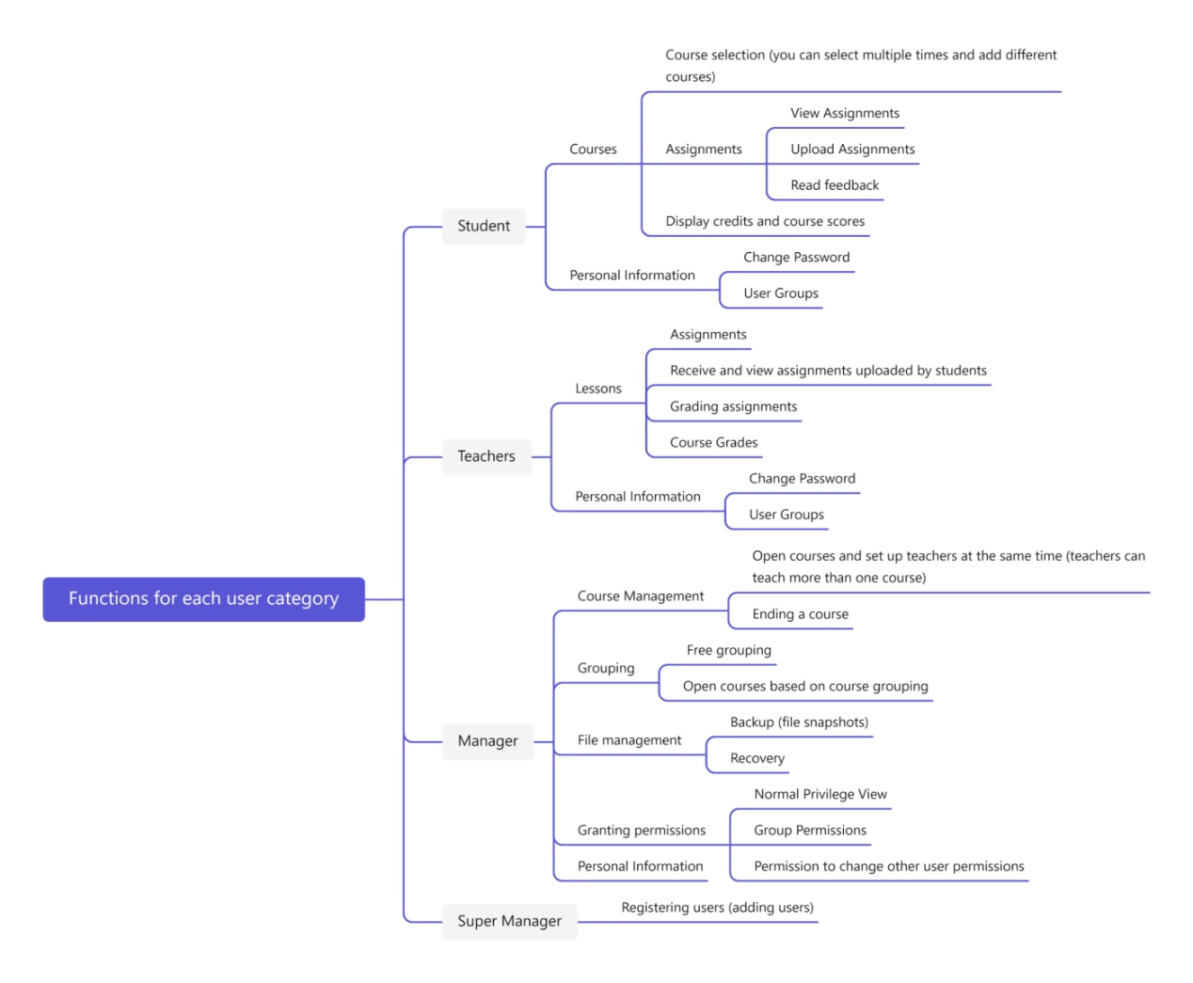
The system function is mainly divided into two parts: course function and authority function.
The course functions are divided into three roles: student, teacher and administrator. Administrators can open courses, start courses, and end courses. Students can choose courses, view homework, upload homework, view homework feedback, and view the total grade of the course. Teachers can assign homework, view student work, correct homework, and set the total grade of the course.
The permission function is used by the administrator. Administrators can freely group and assign permissions to individuals or groups.
The super administrator can only register new users.

System commands
The system commands are implemented in order to better demonstrate the file management and permission operation functions. The prompt interface displayed on the user side is shown in the figure containing all the implemented file system functions.
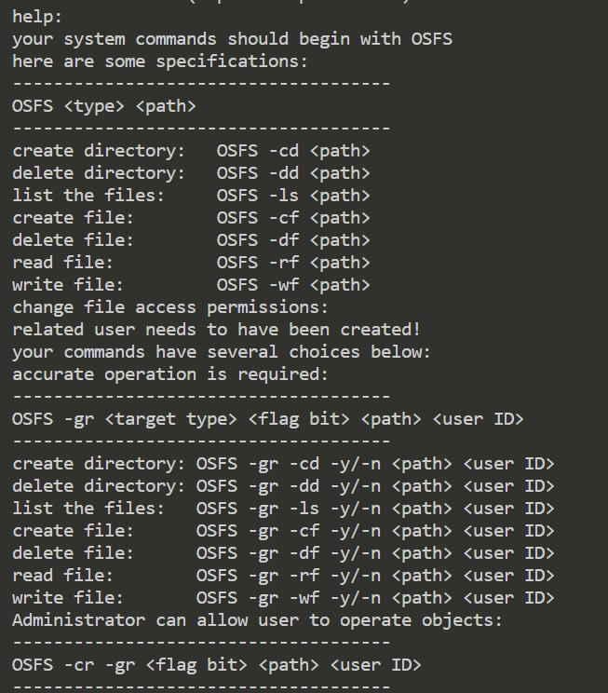
These are all the implemented system commands, divided into three main blocks. First there are the seven basic file operations: create directory, delete directory, create file, delete file, list all files, read file, write file.
Then there are the seven basic permissions operations that correspond to changing the permissions of others.
As well as the one operation of giving users the permission to change other people's permissions.
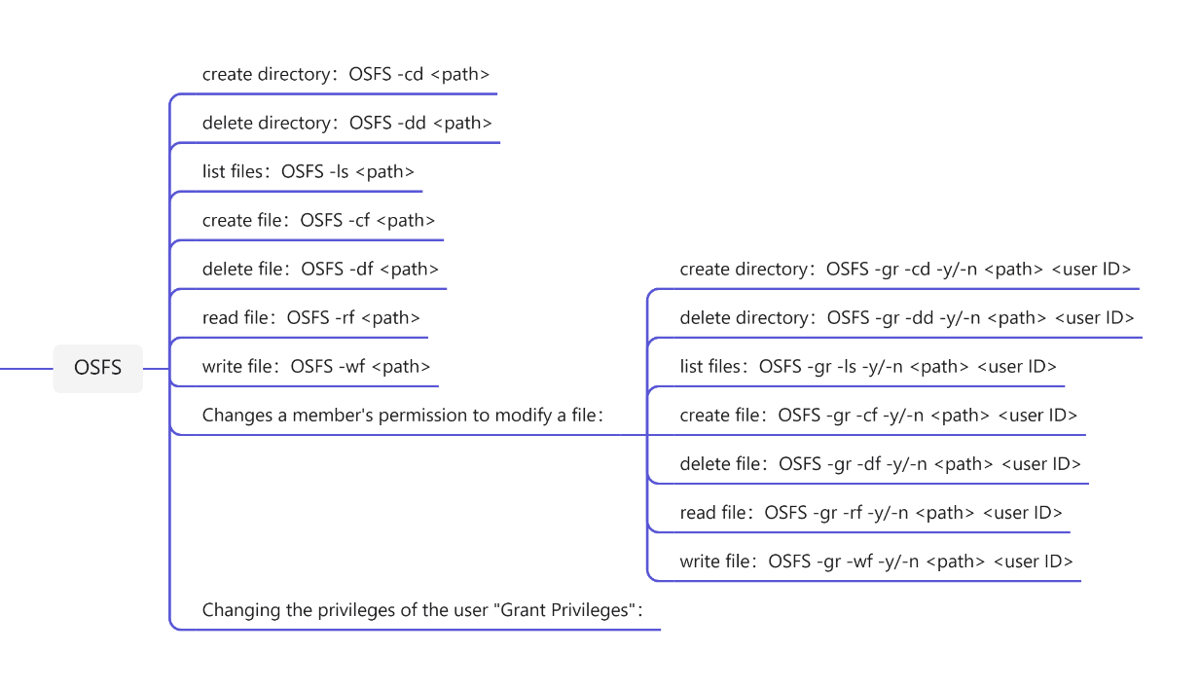

Technical Analysis

Communication protocol
- Special address identifiers
  - Purpose
Since all terminals listen to local ports, competition inevitably occurs in the process. To solve this problem, we use a five-digit ID for each terminal. When sending a package, we will add a header to the package to identify it.
  - The network packet header
Identify each endpoint: 10000 – 19999 address
Package with added header (in parentheses):
(Operation type | Destination | place of issue) content
Here are some examples for operation type:
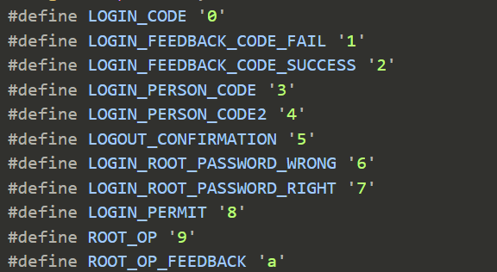
  - Special address
10000 server ports
10001 The fictitious address at the time of request
- Correctness check
According to the needs of the system, we have designed two verification methods to solve the problem of parcel delivery before having a real address and the parcel delivery problem after having a real address.
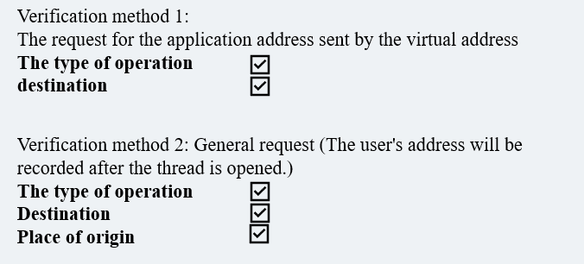
- Error handling
The situation is shown in the image when the wrong package is received.
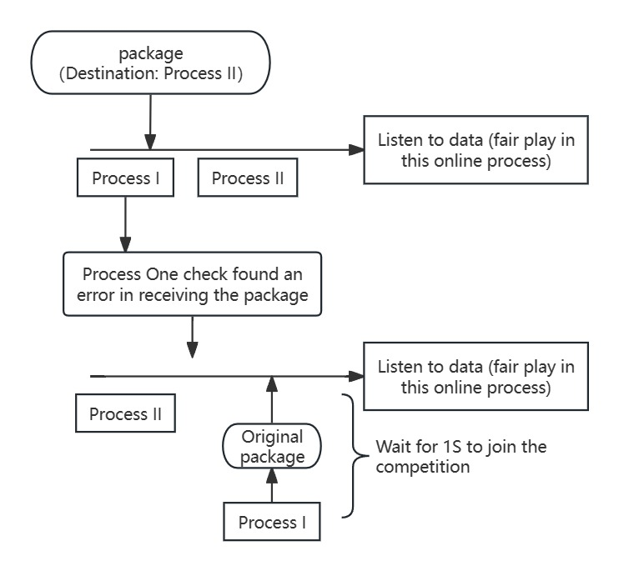
After correctness check, process I finds that the package is wrong.
Process 1 cedes resources by voluntarily exiting the competition.

Option management - Opcode
- Composition of the op_code
We flattened all the options in a one-dimensional array and added unique opcodes to identify them. The opcodes is shown below:
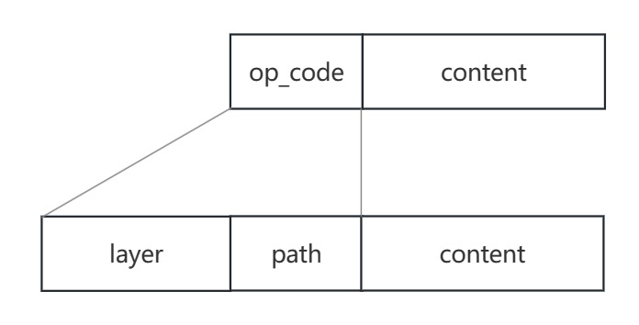
Layer: layer represents the number of levels on the user's current page, the initial level is 1, and when the level decreases to 0, it means that the user exits. Therefore, the user's real-time layer also represents the user's state.
Path: path indicates the path where this option is located. This design is tantamount to turning a hierarchical structure into a flat structure. path is a hierarchical information that records the current option.
Here are some examples:
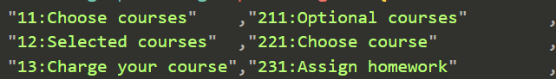
The server side stores the current layer and current path for each user.
- How to use
When the user needs to display the option information, the server will compare the entire list of options, find the options that match the hierarchy and path, arrange them, and return them to the user.
When the user's options are returned, the server-side will map the user's choices to the real ones via a hash table. After that, the server side will get the op_code by connecting the layer, path, and user's choice.
- Advantages
Since each option is identified by an opcode, we can use a function to handle these opcodes in an integrated manner.

Basic implementation of file system
Based on lab4, we have implemented 7 basic file operations, including Create Directory, Delete Directory, List File, Create File, Delete File, Read File, and Write File.
In fact, the basic idea of ​​each operation is very consistent: first locate, and then operate the child inode, parent inode, child block, parent block, and bitmap.
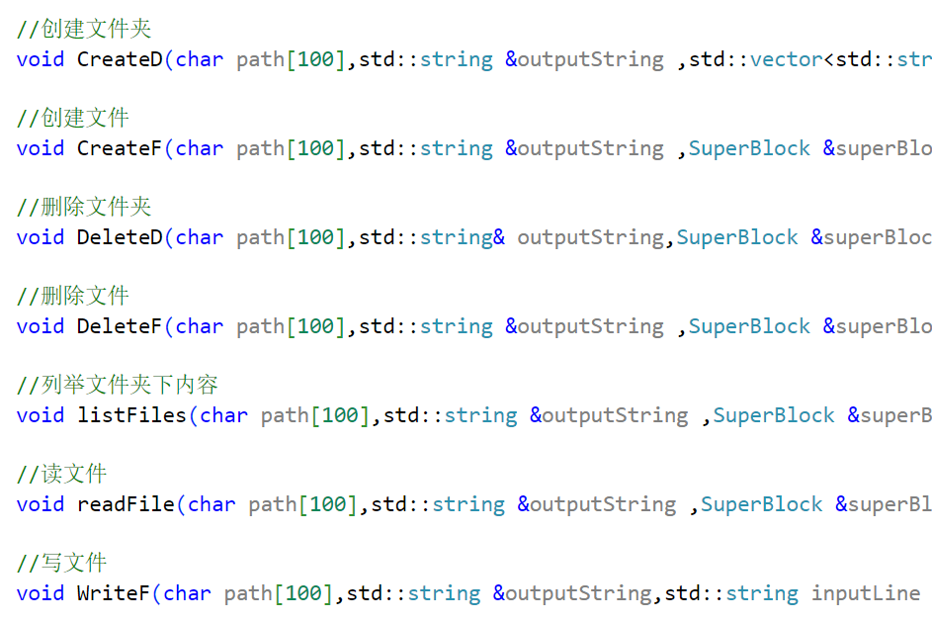
- Delete Directory
Here we only focus on one Delete Directory. Because he involves the deletion of his directory entries. Here we use the DFS algorithm to traverse its directory entries. An example is shown below.
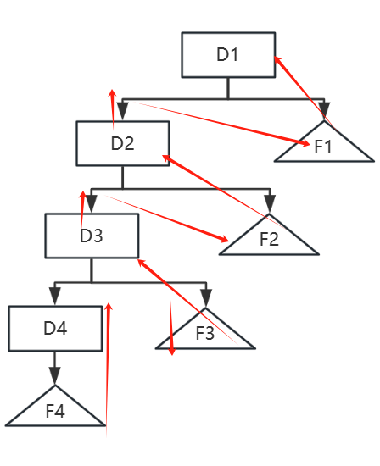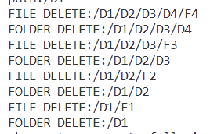

- Allow files and folders with the same name
This system distinguishes files and folders by type, allowing files and folders to have the same name in the same directory.
To achieve this, you need to determine the file type at the same time every time you search. The following is the relevant code.
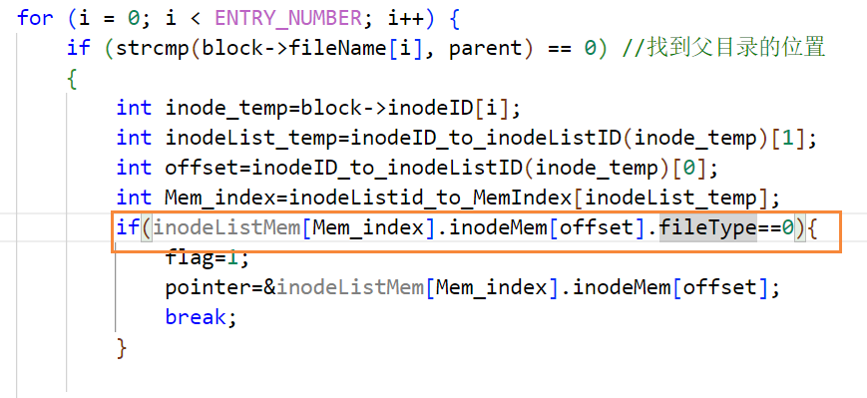

Reading and writing large files
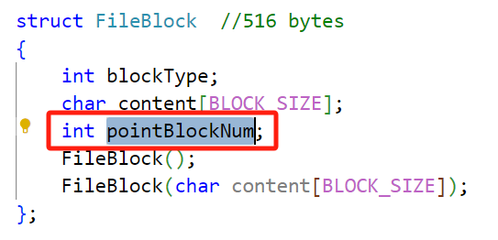
In order to realize large file reading and writing, we changed the structure of FileBlock on the original basis. Add a pointer to the end of FileBlock. Point to the next FileBlock until the end of the file, and set the tail pointer of the block to -1.
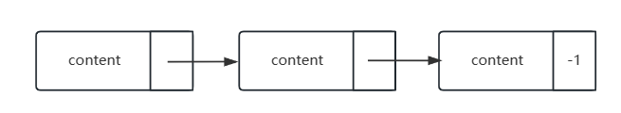
Pay attention to deletion and write operations here.
- Deletion requires deleting all blocks and breaking the intermediate connection pointers.
- For write operations, the block must be operated under the current connection, and then the unused blocks must be released.

Inode dynamic expansion
Our system implements dynamic expansion of inodes. The specific idea is: when all existing blocks are full, we will automatically expand the next level of inode. This kind of expansion provides three situations: first-level expansion, second-level expansion, and third-level expansion.
- first-level expansion：10 block->19 block
- second-level expansion：19 block->118 block
- third -level expansion：118 block->1117 block
Specifically from the code level, to implement inode expansion, the following operations must be implemented.
- Determine whether expansion is needed
Mainly by comparing the existing block is full, here by accumulating full to judge how much level’s full it has reached.
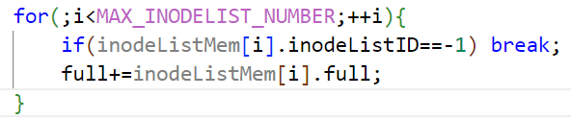
- Initialize the newly expanded inodeList
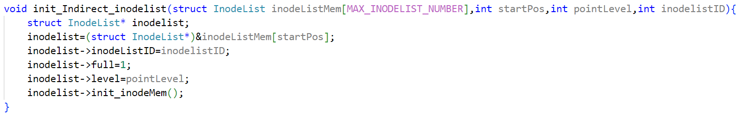
- Change the link block of the root node to the outermost 0-bit inode.
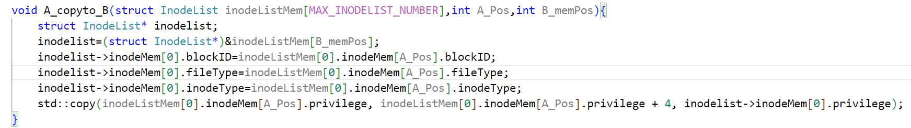
- Change the category of the middle inode to IndirectInode.
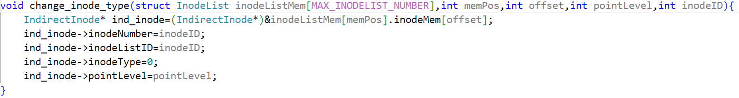
- Change the link information of "the link block of the root node"
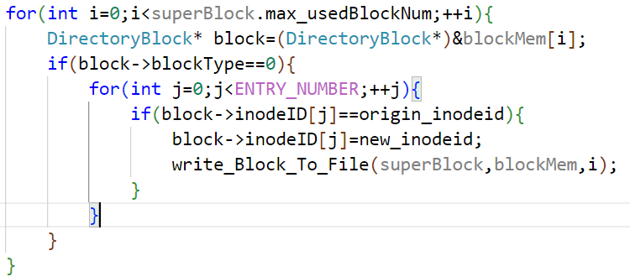

System snapshot and recovery
- System snapshot
We use incremental and modified file snapshot recording. We use log files to record addition and modification log information. The hash file and copy_files folder are used to record changed file information.
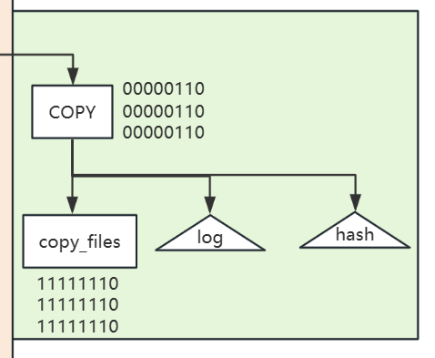
  - Log
log format: opcode, path;
opcode：
- 0: Create folder
- 1: Create file
- 2: Delete File
- 3: Delete files in a folder which is deleted
- 4: Delete folder in a folder which is deleted
- 6: Write file
- 7: Add user
- 8: Change password
Log entrys are recorded by pushing onto the stack. In this way, when restoring, you can directly restore by popping from the top of the stack.
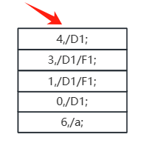
  - copy_files & hash
copy_files is a folder that records files before changes. Consider the length limit of file names. We will change the file name of the original file in copy_files. At the same time, a hash file is used to record the correspondence between the changed file name and the original file name.
- System recovery
Recovery is to continuously read log information from the top of the stack of the log file, and achieve system recovery in this order.
The specific operation of recovery is to identify the operation code, find the file before the change according to the hash file, and execute the SQL statement to restore the database.
The opcodes and corresponding recovery operations are as follows:：
- 0: Delete folder
- 1: Delete file
- 2: Create file + write file
- 3: Create File + Write File
- 4: Create Folder
- 6: Write File
- 7: Delete user
- 8: Change password

Inter class design of student management system
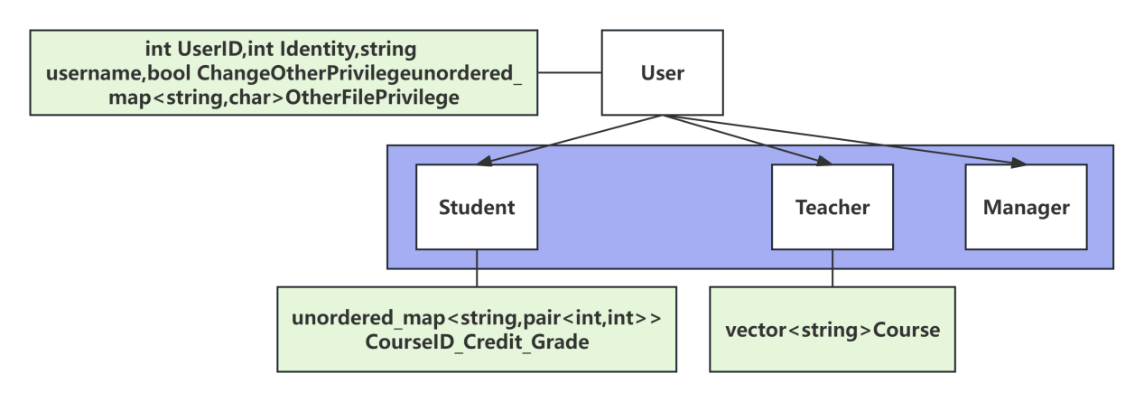
Interclass design diagram
In order to manage permission information and course information respectively, we use C++ inheritance mechanism to design the base class User, which stores permission information and user basic information, and the subclasses Student and Teacher, which store course information.
In the student management system, the number of permission allocation is much less than the number of permission query, so the base class uses a hash table to store the permission information to improve the query efficiency. At the same time, the base class provides the method of adding, deleting, modifying and checking the permission information for the system function to call.
In the subclass design, since the teacher only stores the taught courses, the vector type can be used to store. The students' course scores are queried more often, and are stored by hash table.

H2S read write protocol
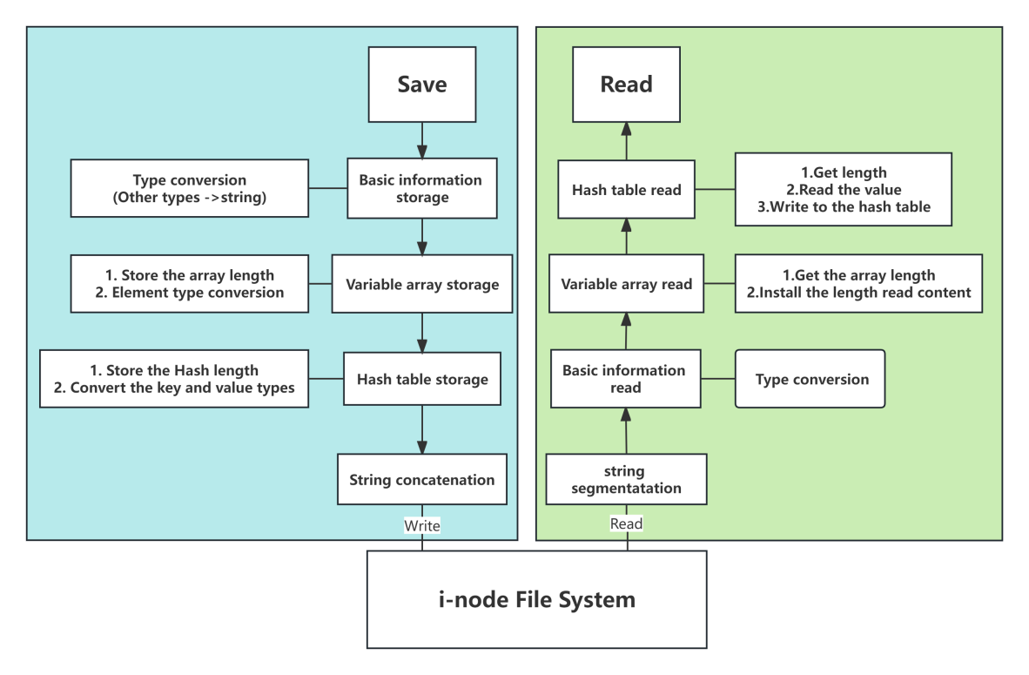
H2S protocol
Since our class has data of various data types, we need to convert them into strings and store them in the file system, so we need to define a custom read and write protocol for the storage and reading of class information.
Basic types, such as Booleans and integers, are simply converted to strings.
Variable length arrays, such as vector, record the length first, and then record the data in a way that changes to a string.
Hash table structures, such as unordered_map, record the length first, then record the keyword, and finally record the data. Note that the separators between keywords need to be different from the separators between data.

Database operation of inherent information
- Basic information
There is a lot of normalized and inherent data in the system, such as the basic information of all courses and the personal information of the users who have been created. So we used MySQL to store that data.
We created a database called OS to store the data. In this database, we have created two tables. Their information will be shown in the image below.
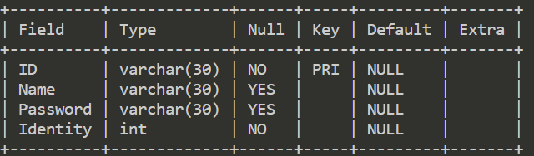
Users
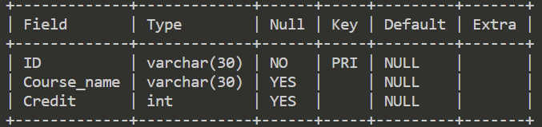
Course
- Login operation
When a login request arrives, the database is queried. The query is performed based on the user's ID.
Compare steps:
- Check the size of the result (0 block)
- Compare the password (wrong block)
- Compare the identity (wrong block)
- Login
- Password operation
When the password change function is executed, the update statement of the database will be called. The query is performed based on the user's ID too.
Steps to perform:
- Check the size of the result (0 block)
- Compare the old password with the input (wrong block)
- Update the password

User group design
Group information is a hash table structure, key is the group name, value is the group member vector, and is stored separately in the group file under the root directory of the file system.
The Group class provides methods for storing and reading, adding, deleting, and checking for system function calls.

Permission technology
Permissions In our system, there are two concepts: group permissions and individual permissions. In other words, when granting permissions, there are two ways to grant group permissions and individual permissions.
The types of permissions we provide are shown in 2.1.5.

- Permission setting
- Basic permissions
The so-called basic permissions are the corresponding permissions that users have for each file and folder operation after registration.
- storage
The basic permission settings are directly embedded in the file system. A char[4] data structure is used for storage in the inode.
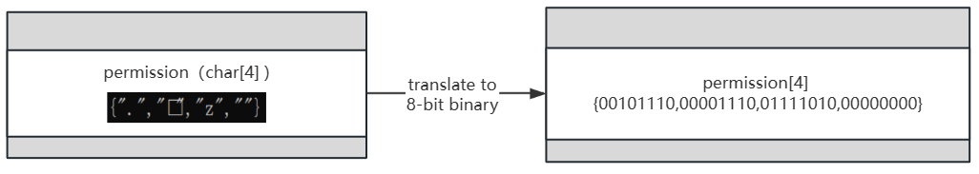
Within the array of Char[4]:
- The first element: permission information for user type Student
- The second element: permission information for user type Teacher
- The third element: permission information of user type administrator
- The 4th element: empty, used to fill the position and build a data structure that is a multiple of 4.
- Assignment
For folders, permissions need to be set explicitly when creating the folder. If not set, the system will set the permissions of the folder to the default value.
For File, there is no need to explicitly set permissions. File's permissions are inherited from its parent folder to a certain extent. Specifically, the file permissions: inherit bits 6/7/8 of the parent folder, and 0 in other locations.
The reason why it can be set like this is because for File, the first five digits are meaningless, that is, the user will not create a folder under a file, etc. So directly set the permission to 0 to implement error checking.
The picture below shows a specific example.
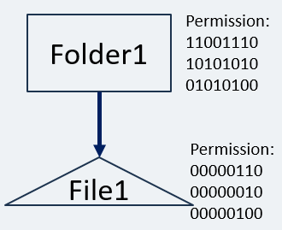
- Specific permission
- Specific permission setting
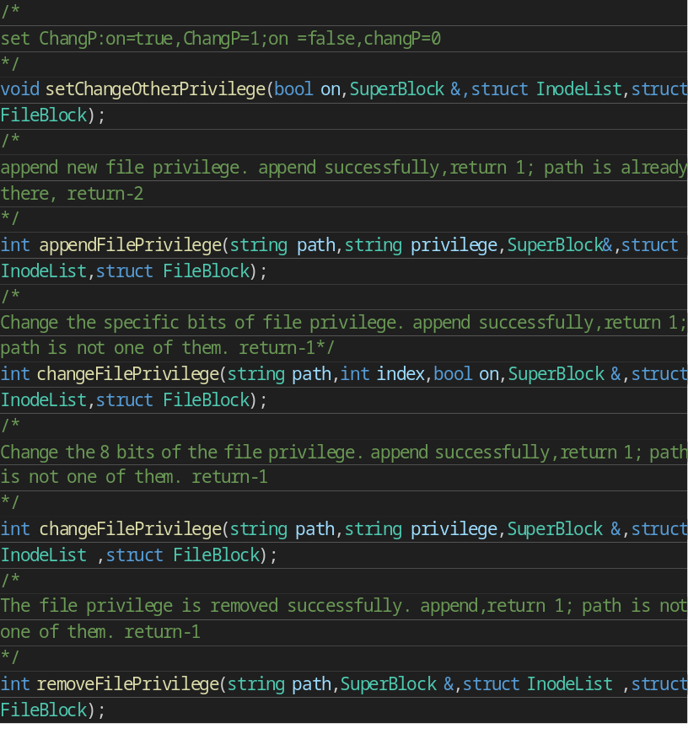
- Special access view
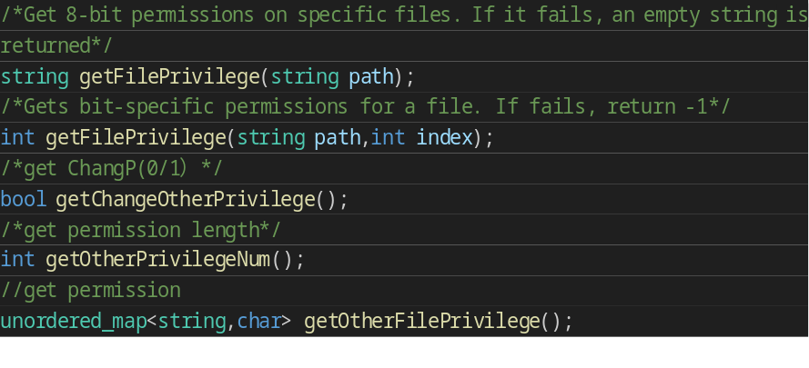
- Group permission granted
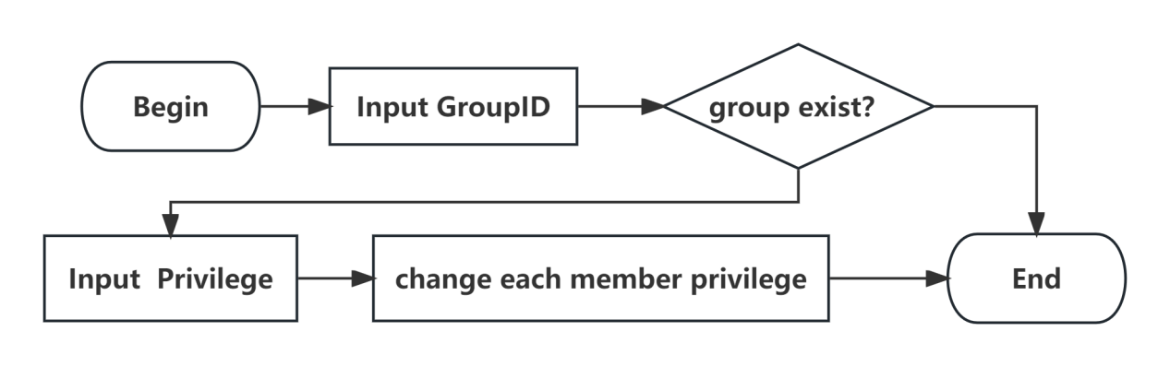
Based on the group number entered by the user, iterate through the group members and modify the special permission table for each member.
- Permission judgment
- If administrator
Administrator can have all file operation permissions, permissions to change others' permissions, and permissions to give users the ability to change others' permissions.
- Checks the permissions of a specific file in this path for this specified user.
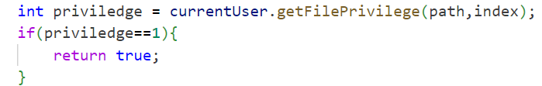
- Check if the corresponding specific permissions are available for the i-node in this location.
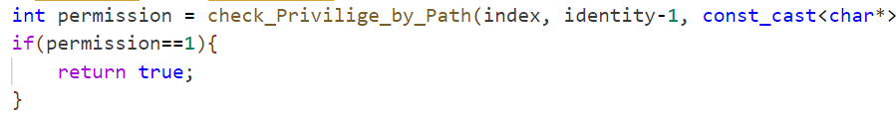

Instructions for Running the Experiment

Preparation

3.1.1 Prepare MySQL
Install MySQL in Ubuntu
(https://blog.csdn.net/fanrongwoaini/article/details/107518693)
Command: sudo apt-get install mysql-server -y

3.1.2 Preparation for the database:SQL
create Database OS;
use OS;

create TABLE course (
ID varchar(30) NOT NULL,
Course_name varchar(30),
Credit INT,
PRIMARY KEY(ID)) ;

create TABLE users(
ID varchar(30) NOT NULL,
Name varchar(30),
Password varchar(30),
Identity INT NOT NULL,
PRIMARY KEY(ID));

insert into course values('CS101','Computer Science',2);
insert into course values('CS201','Data Structure',4);
insert into course values('CS505','C++ Programming',3);
insert into course values('CS809','Python',2);
insert into course values('B0103','Organic Chemistry',3);
insert into course values('B0511','Chemical Experiment',2);
insert into course values('01109','College Physics',4);
insert into course values('01201','Quantum Mechanics',4);
insert into course values('LA101','Chinese Language',2);
insert into course values('LA255','English Writing',2);

insert into users values('700141','lwj','1',1);
insert into users values('700302','sds','2',2);
insert into users values('700313','qqx','3',3);
insert into users values('200000','root','123456',3);

3.1.3 Preparation for the visitor
SQL:
CREATE USER 'Manager'@'localhost' IDENTIFIED BY '123456';
GRANT ALL PRIVILEGES ON OS.* TO 'Manager'@'localhost';
FLUSH PRIVILEGES;

How to Use

3.2.1 Start the server-side
Command: bash T.sh

3.2.2 Start the user-side
Command: bash U.sh

Presentation of Experimental Results

Display Sequence Chart
In order to better demonstrate all our functions, the picture below shows one of our display sequences.
We will show you in order:
- Basic operation of the student management system
- Course related functions
- Job-related functions
- Grouping function
- Permission granting function (individual granting, group permission granting)
- Large file reading and writing function
- System snapshot and system recovery
- System command
- 7 basic operation commands
- Permission granting command
- Command to grant permissions to “change others’ permissions”
- Associated database student management system operation
- Login
- Register
- Change password

What needs special attention is that
Snapshot and recovery operations: Pay attention to whether the file status before backup and the file status after recovery are consistent;Pay attention to whether the database state before backup and the database state after recovery are consistent.
Permission operation: Pay attention to the feedback of users operating a certain file before and after granting permissions.
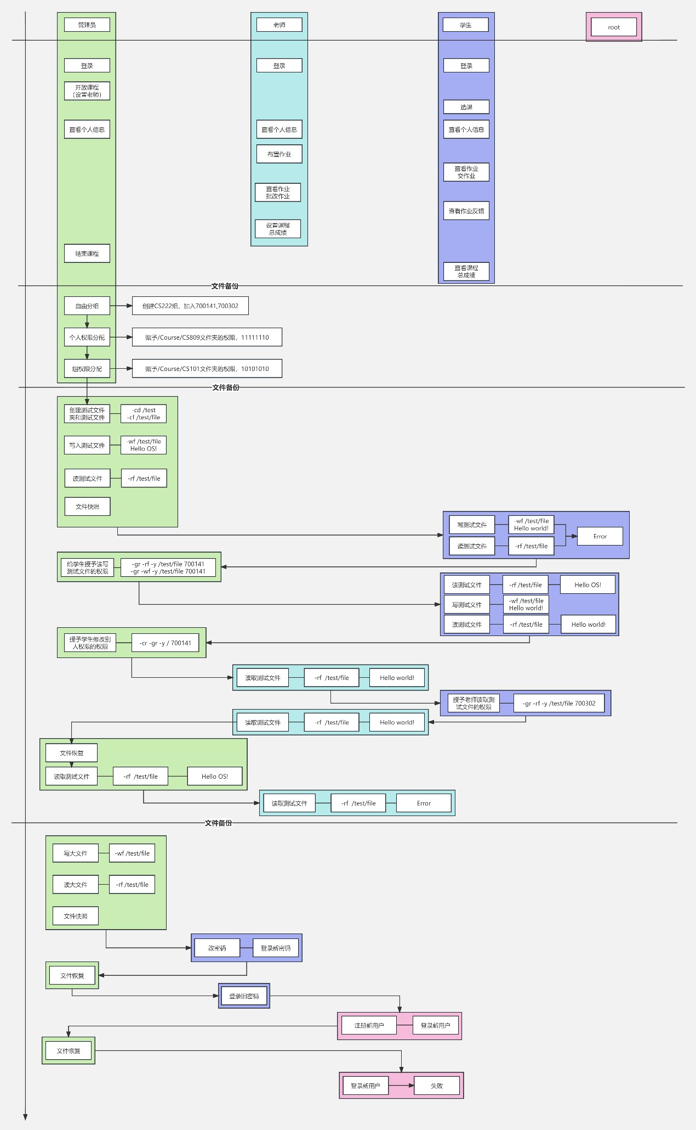

Result
Note: Snapshot and restore operations and permission operations are included in the following operations.

4.2.1 Basic operation of the student management system
- COURSE operation
- Administrator sets the course Teacher
- Operation
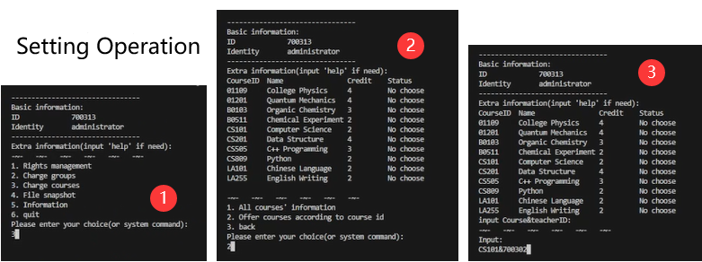
- Status
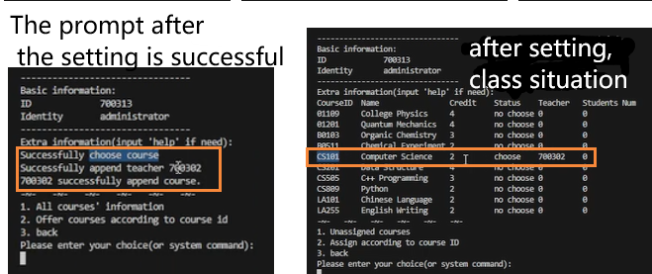
- Student SELECT course
- Operation
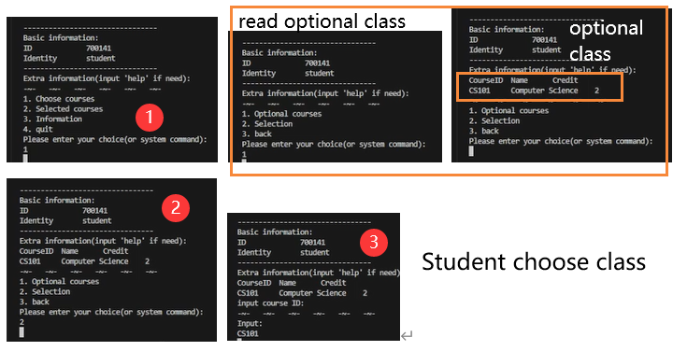
- Status
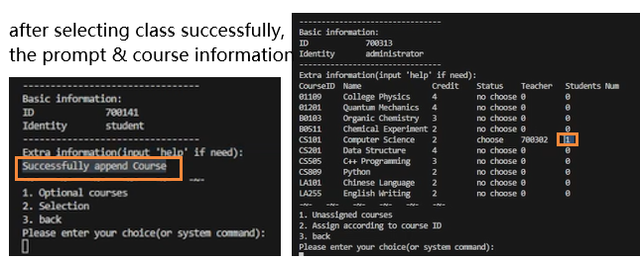
- Administrators ASSIGN courses
- Operation
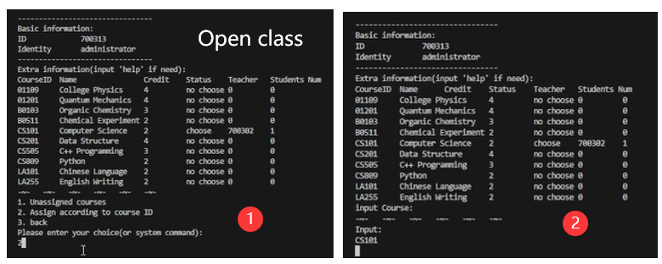
- Status
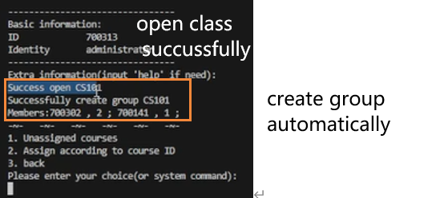
- Teacher set course’s GRADE
- Operation
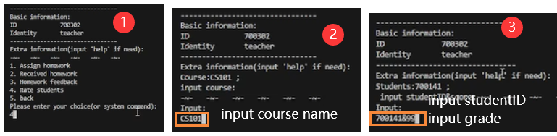
- Status
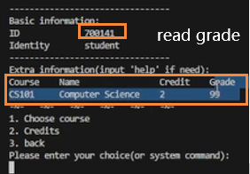\
- Student read course’s GRADE
- Operation
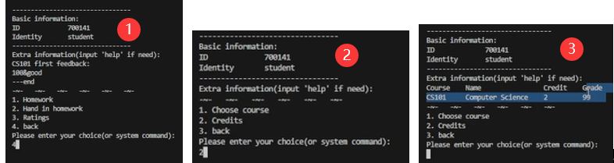
- Status
- Adminstrator CLOSE course
- Operation
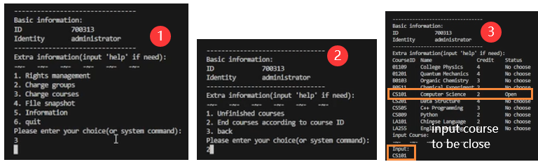
- HOMEWORK Operation
- Teacher ASSIGN homework
- Operation
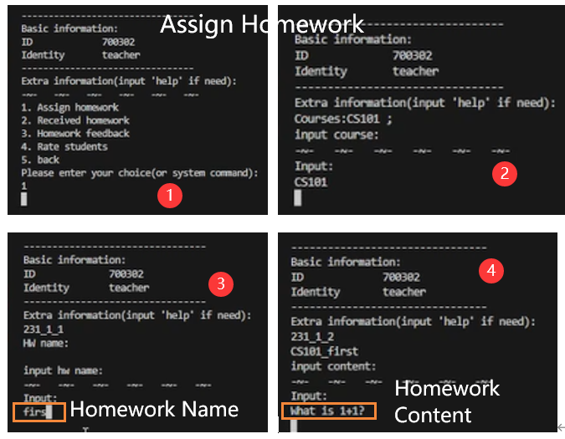
- Status
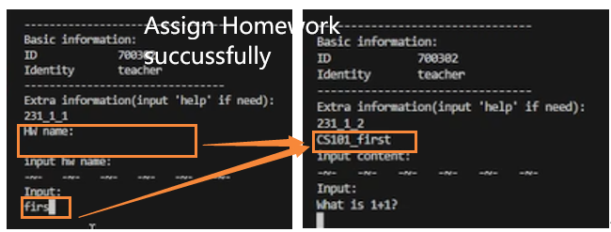
- Student READ homework
- Operation
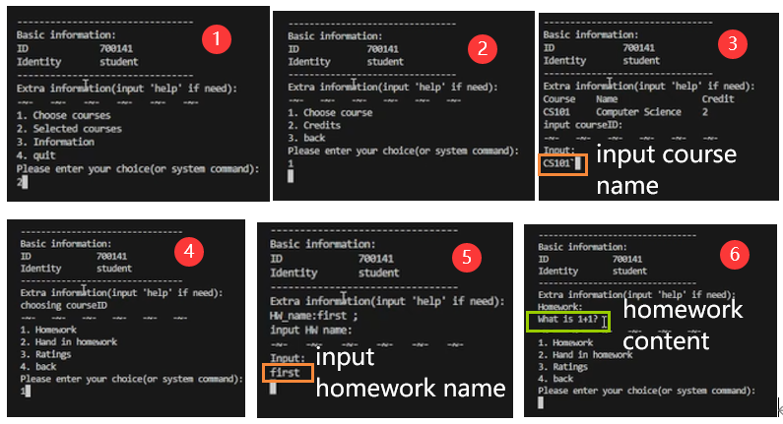
- Status
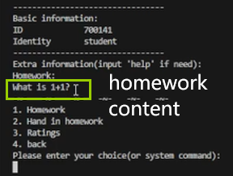
- Student HAND IN homework
- Operation
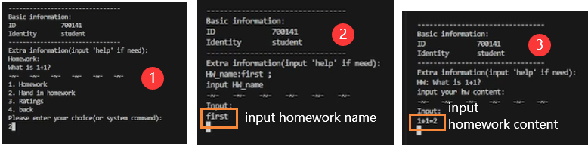
- Status
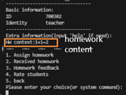
- Teacher READ homework which student hand in
- Operation
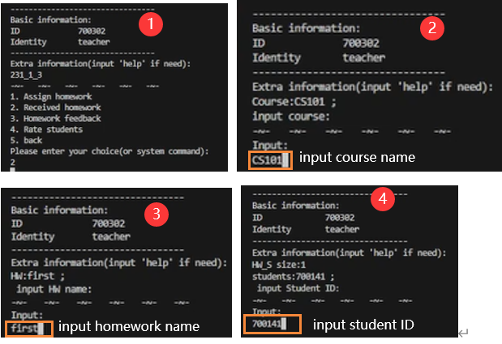
- Status
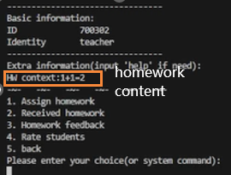
- Teacher give homework GRADE & COMMENT
- Operation
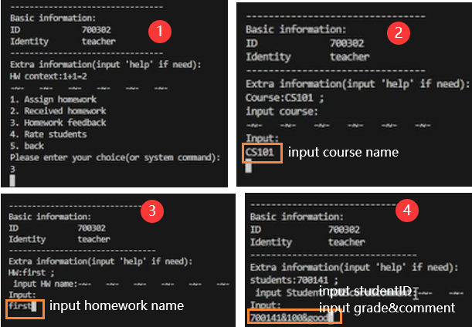
- Status
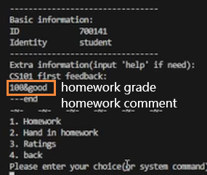
- Student READ homework GRADE & COMMENT
- Operation
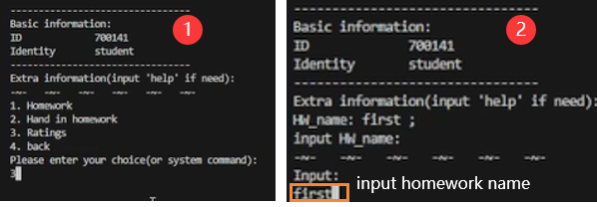
- Status
- GROUP Operation
- Operation
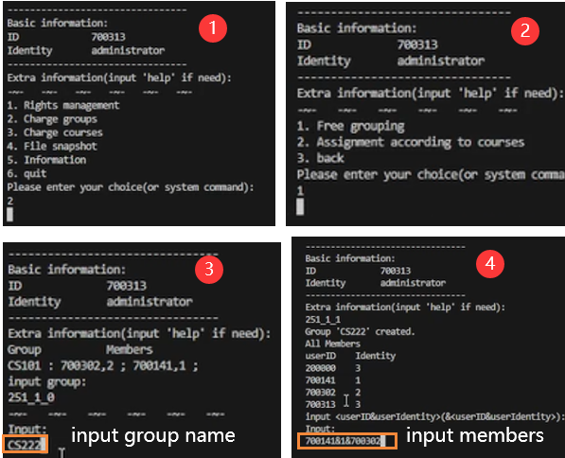
- Status
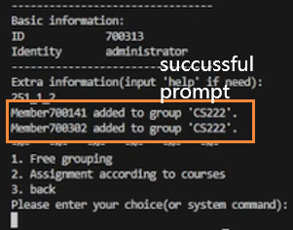
- PERMISSION Operation
- user-level permission
- Operation
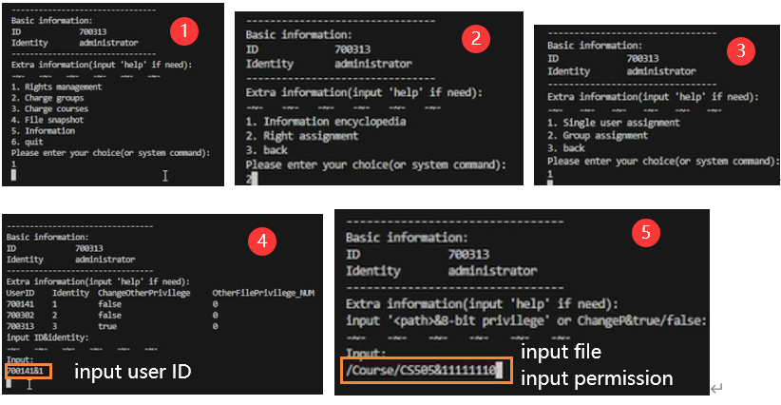
- Status
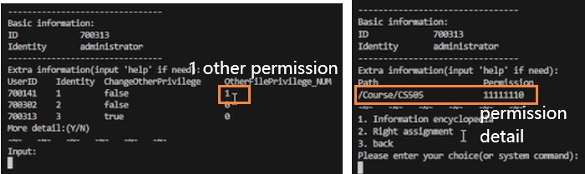
- group-level permission
- Operation
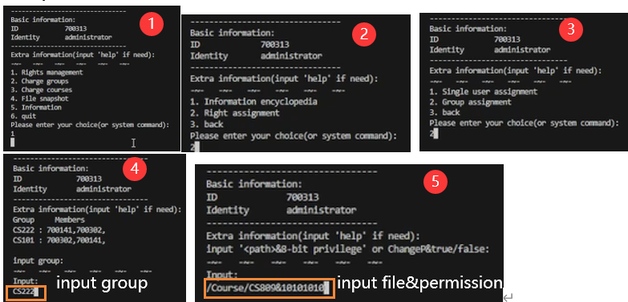
- Status
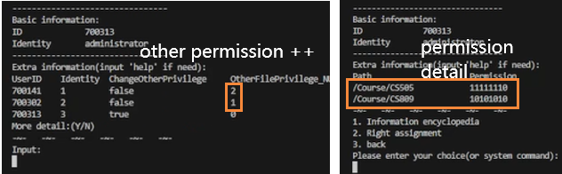

4.2.2 System command
- Create basic test file and test directory
- Operation
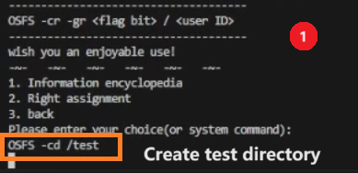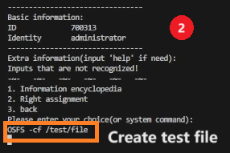
Check:
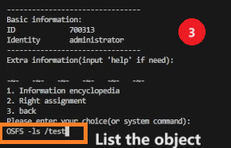
- Status
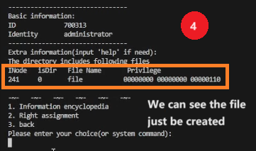
- Write into the file
- Operation
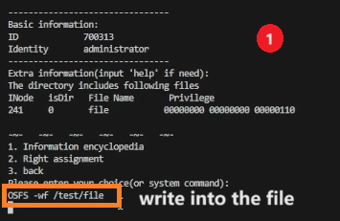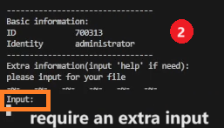
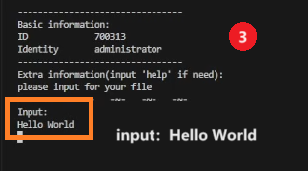
- Status
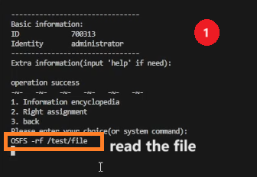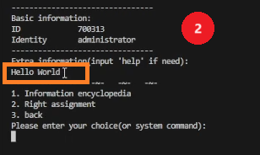
- Give permissions to other users
- Operation
Before:
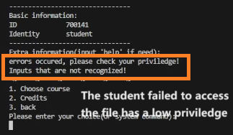
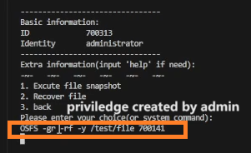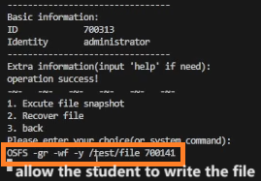
After:
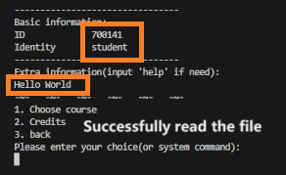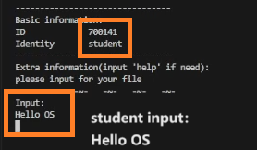
- Allow other users to change others permission
- Operation
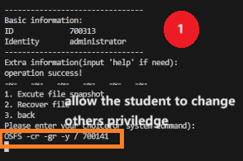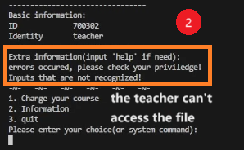
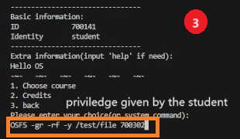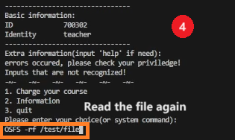
- Status
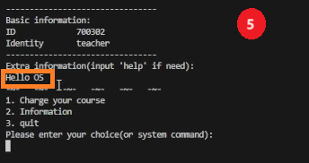
- Perform a backup operation
- Operation
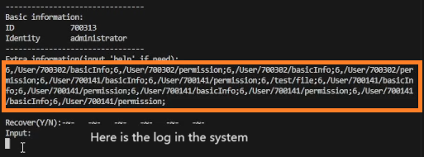
- Status
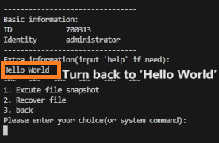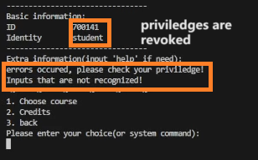
- Large file reads and writes
- Operation
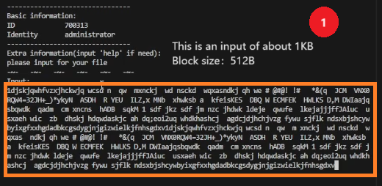
- Status
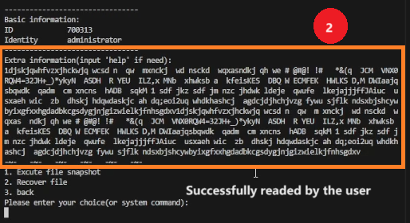

4.2.3 Associated database student management system operation
- Login
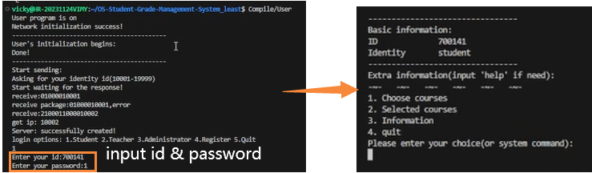
- Logout
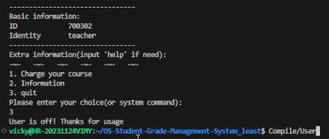
- Register
- Operation
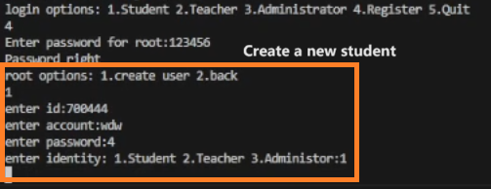
- Status
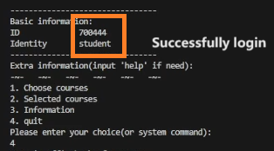
- Change the password
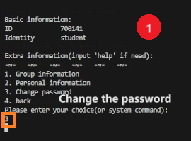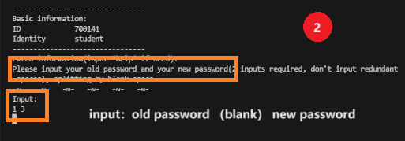

Description of Contributions from Group Members

Overview
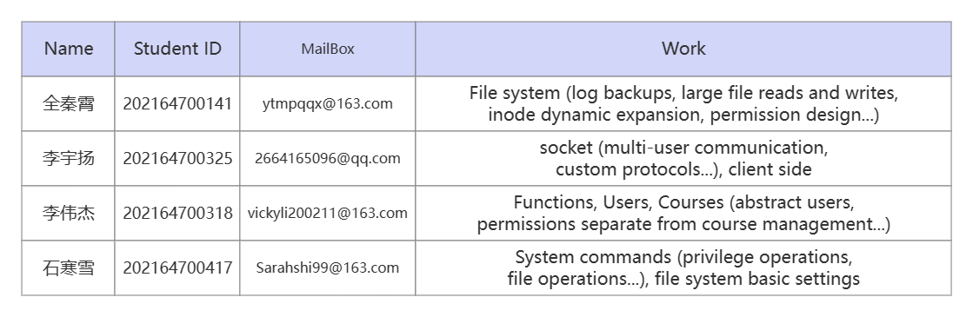

Detailed description
- 全秦霄（team leader）：
- Implement the underlying file system
- Implement the basic functions of the file system
- Realize dynamic expansion of inode
- Realize large file reading and writing
- Implement file snapshot and recovery
- Design and implement permission operations
- Provide interactive interface
② Design and build the file structure of the project
- Design the overall structure
- Design embedded permissions
③ As the team leader, coordinate the project
- Coordinate project progress and division of labor
- Build project framework
- Provide document structure
- 李宇扬
- Implement the basic architecture of the project
- Realize network remote communication
- Enable multi-user communication
- Server-side multithreading implementation
- Custom protocols handle conflicts
- Client-side implementation
- Opcode-related operations are implemented
- Dialog structure implementation
- Opcode processing framework implementation
- MYSQL setup and operation
- Login inquiry, password inquiry
- Query the total information of the course
- Create a user in the database
- Basic function implementation
- Change the password
- User status logging and updating
- System status logging and updating
- The user-side page turning operation
- 李伟杰
- Build user and course categories
- Implement storage and reading of class attributes to the file system
- Implement separate management of user's course information and permission information
- Implement System Functionality
- Illegal Input Check
- Functional Business Logic Implementation
- System Framework Optimization
- Integrate various parts of the code
- Write system manual
- 石寒雪
- Building part of the basic structure of the file system
- Basic Course class permission settings
- Permission settings for pre-set courses
- System Command Implementation
- Basic file operation commands
- Granting others file operation permissions
- Granting users the authority to change the permissions of others
- Permission judgment before file system operation
- User identity judgment, different users have different execution permissions
- Specify the user's corresponding permission check for files in this path
- Specific file permission checks for different categories of users corresponding to inodes in specified locations

